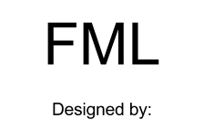











**Theme**

The themes for our game are revenge and passive aggression. Have a bad boss? Play this game and stress out the boss to get your anger out. Plus you can do it while having fun! You can play cards that make everybody else’s lives difficult if you’re the boss, which is great if you need to blow off some steam. The point of the game is to screw over your boss (or employees if you are the boss), and exact revenge on those in life that stress you out.

**Genre**

Our game’s genre is a one versus many, turn-based, tabletop game. It’s focused around a clock shaped board that players will move around continuously until the winning conditions have been met. The players are organized into two groups referred to as the workers and the boss, with the boss being only one player. Each player will have a turn in a decided order where they will roll their dice and move, as well as possibly play one the cards they have collected while traversing the board.

**Setting**

The main setting will be a generic office building where both the boss and the employees work. The daily hassles of corporate office life will alter the stress levels of the building’s inhabitants. In addition, the board will also encompass the lives of the players, starting from getting up in the morning and ending with going to bed at night. One revolution of the board will represent one day. Just like corporate life in the real world, this cycle is endless and stops only in death or forced retirement.

**Objectives**

The objective of FML is to raise the stress of the opponents while trying to maintain or even reduce your own stress. The “boss” player tries to take down the other players by increasing their stress levels, while the “employee” players team up to try to take down the boss. The boss and employees navigate the circular board and draw cards to determine if stress should be raised or lowered. A player loses the game when his or her stress reaches 100%. The boss must defeat the employee team while the employees must work together to take down the boss.

**Target Audience**

FML is targeted at anybody in the working world, professional or nonprofessional. This range would most likely start around the age of 16 and continue through college and adulthood. Because it is a workplace-centric game, it is focused on those who know the stress of a job and answering to a boss, as well as the camaraderie of coworkers. The game is a struggle of many weaker players versus one stronger one. It has focuses on the fellowship that coworkers experience and the challenge that everybody experiences in the professional world. Throughout the game a narrative is created, telling a story as different cards are drawn at different times.

This game faces the demographic of teens, young adults, and upwards. It is not a skill game, but more like Monopoly or Life. It can be played casually, when people have time, which is good for the adult demographic. Because it is about the workplace, it is centered on an experience that people in these age demographics know -- that of the job world. It is a game about responsibility and stress, which these groups can relate to. This is a game for both males and females. For males there is competition, destruction (raising the enemy players’ stress levels), and trial and error. For women, it is a real world game. There is also learning by example and emotion.

Bartle’s taxonomy of player types can also come into play. FML has something for everyone. For killers, it is simple. They are trying to make the player(s) in the other role quit by raising their stress levels. They have to make them suffer throughout the workweek. Socializers are sated by the interaction between players, which is a main point of the game. Achievers want to win, be it little in-game accolades such as Employee of the Month, or just the game overall. Finally, since the different “times of day” on the board change how cards work, explorers can set out to discover all of these intricacies. They want to figure out how to maximize their efficiency and reducing and protecting their stress levels throughout the game.

**Context**

It is another day in your hard and miserable life. You wake up and and just the thought of going to work again kills you inside. You are tired of going to work every day and having to listen to your clueless boss give you pointless jobs. You go through the days like a drone doing whatever he says without any argument. That is, until today. You have made up your mind that you will no longer take the crap thrown at you day in and day out. You will stand up for yourself as well as your co-workers. You begin to set your plan in motion with the help from your fellow co-workers to make your boss quit. You try to be the worst employee possible, making the life of your boss a living hell.

As for the boss, you are tired of your employees harassing you and not doing their jobs. You need to teach them a lesson. You decide to fight back against the office. The battle ensues day in and day out until one side has had enough.

**History**

This game is a collaboration of several different ideas and other games. It is most closely related to the board games of LIFE and Monopoly, and the card game Munchkin. It is like LIFE and Monopoly because you go around the board and different events occur on different spots. Also like LIFE, each player has a specific “job” as their character which gives you a special ability. These abilities can be used only once per turn at anytime the player chooses, while the efects in LIFE can occur at anytime. It is more similar to Munchkin in the comradery of the gameplay. There are elements of fellowship and teamwork since it is many against one. Also there is a sense of humor in screwing over other players.

FML is different from these games because, for one, the board is a clock. The cards you draw depend on the time you are currently at. Day cards are drawn between 9 and 5, and night cards are drawn between 5 and 9. Also, you can hold cards in your hand unlike LIFE and Monopoly where you play a card as soon as you get it. As similar as FML is to Munchkin, it is also different. In Munchkin you try to be the first one to reach the highest level. In FML, you are trying to stay as far away from the highest level as possible.

The idea of the game stems from the movies Office Space and Visioneers. FML is basically the board game version of Office Space, all the employees hate the boss with a passion, and there is a fire a’brewin in their bellies to teach him/her a lesson. The idea from Visioneers is that people are beginning to spontaneously combust due to stress in their daily lives.

Ideas are also similar to the Sims and real life. In the Sims you have to manage the needs of yourself while destroying the needs of the other players. Mostly the idea comes from the general hatred and dread of a 9-5 job and the fantasies people might have.

**Part II**

**Game Balancing**

One of our main balancing issues is to make sure the boss is not overpowered. Before we play tested the game, we had the employees start out at 50 stress, while the boss started at 30 stress. We found that this made it easy for the boss to win, as the employees’ stress approached 100 faster than we had anticipated. We fixed this by starting all players out at 50 stress. Another issue we ran into was the balancing of some of the cards. We still need to tweak some of them to make the boss more susceptible to stress, as there are not that many that affect the boss significantly. We also need to change some of the stress variances caused by the cards because some are too much or too little.

**Strategy Vs. Chance**

I would say the overall distribution of the game is 70% chance and 30% strategy. I say this because who wins is largely based on what cards are drawn when, where players land on the board, and what time of day it is. A player cannot control this themselves, so it is left up to chance. What space you land on is controlled by the dice roll, while what cards you pick is controlled by how the deck is shuffled and what order the cards are in. The strategy part has to do with the ability to give your item cards to other players. This can be used to lower the stress of a fellow employee who is close to losing, or increase the stress of the boss so he or she will lose faster. Strategy is also present in deciding when to play the item cards because a player does not have to play them right when they get one. They can wait to play it, as some item cards have different effects at night, or the player may just want to save it to raise or lower stress later in the game.

As far as different types of strategies players use, there are a few different ones. We noticed that some players will play their item cards as soon as they get them, while others simply held on to their cards to be used at a more strategic time. The benefit of playing an item card as soon as one gets it means they get the immediate effect of that card, and it also lets them pick up future item cards without hassle, as a player can only hold two at a time. However, we saw some interesting strategies arise from those who held their item cards. The items were either played at a very advantageous moment, or they were combined with the player abilities to produce great effects. These abilities are detailed in the instructions, and an example of this strategy can be found in the appendices. We had not anticipated the game to have so much strategy, but we were pleasantly surprised at the results.

**Mechanics**

The game is played on a circular board that resembles a clock. All players start at 9 and go around the board continuously. To begin all players roll the die and multiply it by 5, then add 25 to get their starting stress level. So the range of stress levels at the start of the game is from 30 to 65. All players draw Job Cards to figure who is which character in the game (Boss, accountant, etc.). All players begin by drawing two day events two items and one night event. The Boss goes first and turns go in a clockwise circle.

**Turn:** Roll and move that number of spaces. If you land on an event space then pick up a day event card if you are between 9 and 5 or a night event if between 5 and 9. The event card must be played immediately. If you land on an item space then draw an item card and put it in your hand or play it, your choice. If you land on any empty space then don’t draw any cards. One event is allowed to occur during your turn only. If you don’t land on an event space you can play one from your hand (day event between 9 and 5 or night event between 5 and 9). Also, you can play two items per turn, either on yourself or on somebody else. At the end of your turn you can have no more than four cards in your hand.You can either discard cards, play them if possible or give to someone else. If you give a card to someone else that person must have at most four cards after you give them a card.

**Event Cards:** Cards that simulate an office event. Most affect other players, read it to see what happens. Day events occur during the, anyone, anyone? That’s right the day, and night events during the, anyone, anyone? Correct, the night. Some may stay in effect for more than one turn.

**Items:** One shot cards that only affect who they are played on then are discarded immediately after being played.

**Losing:** You are eliminated after your stress reaches 100%. You discard all the cards you have and sit and watch quietly.

**Winning**: For the employees to win, the boss’ stress level must reach 100 and “quit”. For the boss to win, all the employees must reach a level of 100. All employees’ stress increases by 5*(number of employees that have “quit”) at the beginning of every turn, no matter what.

**There Can Only Be One:** Optional winning state where if the Boss quits then the employee with the lowest stress level is the only winner.

**Narrative**

Welcome to Purgatech, your place of work and home-away-from-home. Here you work from sun-up to sun-down, toiling away from behind your cubicle. Your life is a continuous, foggy blur of boredom and repetition; staring at the off-white walls, suffocating under the glare and buzz of fluorescent bulbs, listening to the incessant drone of the other employees. Each day delivers the same tedious reports, the same mind-numbing productivity seminars, the same excruciating customer-service calls. Only one thing has kept you sane all these years: the company coffee machine. This solitary bastion of refuge from the eternal hell of white-collar office life has done what the innumerable bottles of horse tranquilizers couldn’t: it allowed you to get through the day. That is, until your boss decided to remove your savior to cut electricity costs and boosts the office’s bottom line by 0.0012%. Now, with nothing left, you and the few fellow employees you consider friends band together to deliver some pay-back and show the boss just how stressful an office job can be. You and your compatriots have to drive the boss’ stress up to necessitate an early retirement, but look out, as the boss will be trying to do the same to you. Two teams will enter; one will leave, followed by the other after having declared early retirement. It might be petty, passive aggressive, and ultimately pointless... but they shouldn’t have messed with your coffee machine.

**Characters**

Roles:

In FML, the player’s role is determined by the team that they are a part of. The goal of the employees in FML is to bring down their boss in order to cause a change in their current working situation, while the goal of the boss is to cause the same pain to the employees that they wish upon him. As a result of the format, both sides play the roles as the heroes and villains of this game, since their role is based on their perspective of the other team.

Function:

Relative to the team of employees, there is no actual leader as they work cooperatively to take down their boss. The players are mainly blank slates without defined personalities, in order to let someone project their own personality and situation onto them, should they desire to do so. As a result, the employees mainly function as equals and allies to one another, unless the players decide to impose their own relations. Between the boss and the employees, they function as enemies of each other, with little other relation as a result of their current goal.

**Tag Line**

The boss shouldn’t have messed with the coffee machine.

**Illustration of the Game Space (old vs new)**

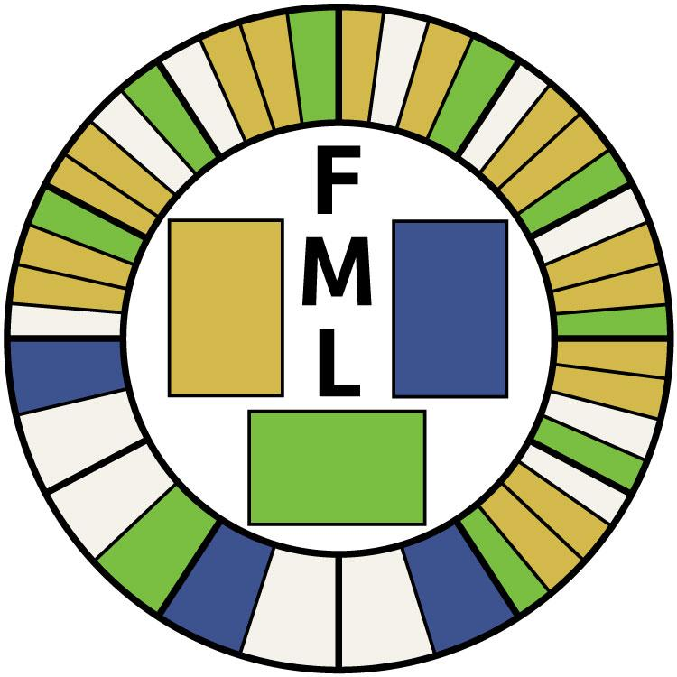

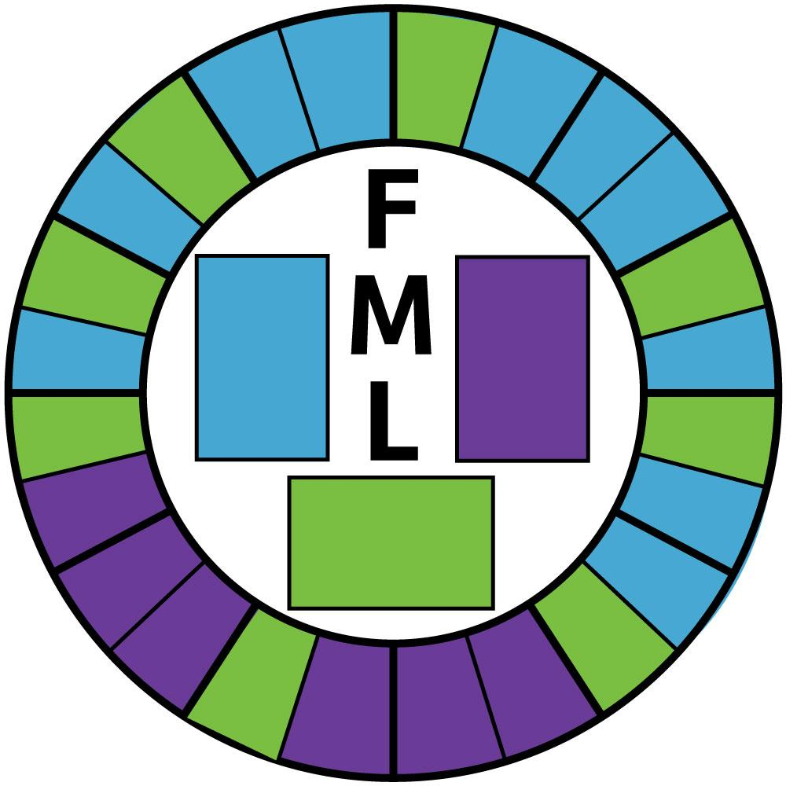

|  |  |
| --- | --- |
| FML-Cards.jpg | FML-Cards2.jpg |

**Part III**

**Walk Through the Gameplay**

The players start by picking their roles at random. One person has to be the boss while the others are employees. The boss is trying get the employees to quit and visa versa. A player quits when his or her stress reaches 100. Every player begins the game at the “9:00” position, which is on the left side of the board. The player rolls the die determine how many spaces to move. The board is situated like a clock with twelve hours arranged in a circular pattern and two spaces per hour. The player will draw cards (day, night, and item) based on the space that he or she lands on. The three spaces are just like the cards: day (blue), night (purple), and item (green). The “day” portion of the board is from “9:00” to “5:00” and the “night” is from “5:00” to “9:00”. The Generally, day cards raise stress, night cards reduce it, and item cards are wild cards that the player can choose when to play (the day and night cards have to be played as soon as they are drawn). Every player has to keep their stress below 100 or else they lose and withdraw from the game. If the boss quits before all of the players, than the employees win, while the boss wins if he or she out lasts all of the employees. While the employees all have character-specific abilities, many of the cards favor the boss over the others meaning that the boss can easily fight off five employees at once. If the boss quits before the employees, the winners have the option to continue playing until only one is left.

**Level Design and Balancing Issues/Consideration**

When designing our level, we modeled the game board somewhat after Monopoly, in that the player continuously moves around the board, without a real end to reach. When playtesting, we did not receive too much negative feedback on the initial design of our board. As you can see by the before and after pictures, our board is relatively the same as it was for our first prototype. The only differences are that each hour has only two spaces, instead of four. Playtesting found that the board was a little too cramped, and that the extra spaces per hour made the player’s stress go up faster, therefore making them lose quicker. Also, we made the board considerably larger, as before we just had a small cardboard circle as the game board. This allowed us to fix another issue that came up in playtesting, which was the fact that the game spaces were too small to fit multiple players on each space. Our new game board is much larger, and one can easily fit every player piece on one space. Another change with the board is the fact that we changed the color scheme. However, this was purely for aesthetic reasons and not based on any feedback we received.

As far as balancing issues, we had a lot of those. When we playtested the game ourselves, we did not see any huge issues with balancing. We originally thought that some of the cards would be overpowered, but we decided to test them out to see how they worked in the game. For the first official playtest that we did in class, we got some feedback that the game was a little unbalanced and that specific cards were overpowered, so before the next playtest we went back and rebalanced some of the cards, but not all of them. After the anonymous playtest, however, all of the feedback was that the game was way too unbalanced. The testers found that they were losing the game very quickly and that they barely made it through a single work day (one revolution around the board). They also felt that the starting stress levels (which varied depending on the players roll) were too high, as in the most extreme case a player could start with 60/100 stress. These results surprised us because when we played the game ourselves, each player lasted for quite some time. However, we knew the playtesters were right, so we went back and instead of just changing some of the cards, we changed all of them. The stress variations on the cards now rarely go above 10, whereas before they were frequently at 10 or above. Also, we made some of the cards that were very overpowered more fair, but we do still have one card that we intentionally left overpowered (the Stuck in the Elevator card). We also changed the starting stress levels so that each player started at zero, rather than having them vary for each player. When playtesting the game again after these changes, we found the game to last much longer. It was much more balanced, and we actually went around the board quite a few times. However, we felt that the game was going way too slow because after playing the game for about an hour, only one player was above 50 stress. To alleviate this, we decided to start the players’ stress at 50 again. This seemed to work much better with the improved balancing.

**Single Line**

Office Space meets the Game of Life

**Description of how similar game(s) faired in profits/units sold**

The games that were drawn from for FML were LIFE, Monopoly, and Munchkin. In case you didn’t know, those games did and are still doing pretty well. Munchkin online ranges from about 10 dollars to up to 35 dollars for the biggest set. Munchkin accounted for 75% of Steve Jackson Games’ profits in 2012, which was over 7 million dollars. Out of their top forty games based on profits, Munchkin and just some of its expansions had 33 of those spots. Monopoly has sold over 275 million copies worldwide. The original version is about 18 dollars on the Hasbro website. The Game of Life sells for just under 20 dollars online. Life also sells for about 20 dollars, depending on where you buy it. Its original version has sold over 50 million copies worldwide. Both Monopoly and Life also have tons of spin-offs and different versions.

**Expected Development Costs**

Wages: $15 for 5 people

Cards: $0.50

Board and Pieces: $1

Total Cost: $25.50

The development costs of the game, in terms of materials are fairly low. The required materials include colored paper and ink for the cards, a foldable piece of foam board for the game board, small wooden hats for the pieces, paper and pencils for the stress recording, and materials to color all of these that require it and mark up the game board. The cards are the cheapest the element, as the paper that is required for them can be purchased in large amounts for a cheap price, allowing each game set to only cost about $0.50 in paper and ink. The board and game pieces cost about $9.00 per set, while the materials used to color and mark them up average about $1.00 per set when considering the ability to purchase them in bulk. The last and most expensive development cost is the combined wage of our five workers, which was estimated at about $15 for the team, per game. Overall, the total expected development costs for each set of our game totals $25.50.

**Time to Develop**

The time to develop a single finished version of the game would take just a few months at most, if we put our full time into it to make it perfect. Doing more playtesting and coming up with more cards would take up most of the time. Making the actual game would not take up that much time. It shouldn’t take more than a working day to put together one full game. You have to print out all the cards, and cut them out. Then color the pieces, and cut the board and color it. The coloring would take the longest at about half an hour, coloring in all twenty four spaces.

**FML**

*Welcome to Purgatech, your place of work and home-away-from-home. Here you work from sun-up to sun-down, toiling away from behind your cubicle. Your life is a continuous, foggy blur of boredom and repetition; staring at the off-white walls, suffocating under the glare and buzz of fluorescent bulbs, listening to the incessant drone of the other employees. Each day delivers the same tedious reports, the same mind-numbing productivity seminars, the same excruciating customer-service calls. Only one thing has kept you sane all these years: the company coffee machine. This solitary bastion of refuge from the eternal hell of white-collar office life has done what the innumerable bottles of horse tranquilizers couldn’t: it allowed you to get through the day. That is, until your boss decided to remove your savior to cut electricity costs and boosts the office’s bottom line by 0.0012%. Now, with nothing left, you and the few fellow employees you consider friends band together to deliver some pay-back and show the boss just how stressful an office job can be. You and your compatriots have to drive the boss’ stress up to necessitate an early retirement, but look out, as the boss will be trying to do the same to you. Two teams will enter; one will leave, followed by the other after having declared early retirement. It might be petty, passive aggressive, and ultimately pointless... but they shouldn’t have messed with your coffee machine.*

**Setting Up the Game**

Start by separating the different card types and placing them on the correct spaces on the board (day, night, and item cards). Next, fan out the character cards and have everybody pick one at random (one player MUST be the boss, no matter how many players there are) and reveal it. Each player should keep this card in front of them throughout the game. Each card has a special ability that can be used once a day, except the boss. You should also pick a pawn to represent your character on the board. All players put their pawn on the “Start of Day” space.

One player must keep track of everybody’s stress levels on paper. If somebody volunteers, they do it. Otherwise, the responsibility is thrown onto the accountant (if no accountant, then boss). This player must announce the stress levels at the start of each of their turns. Each player must now get their starting stress level. Starting with the boss and moving counter clockwise, roll the die. Everybody starts with 50 stress.

Gameplay starts with the boss and moves clockwise.

**On Your Turn**

Roll the die and move that number of spaces. If there is a word on the space, draw the appropriate event card (played immediately). If you have items in your inventory, you can use them at any point during your turn. Discard cards to the side of the board after use.

If one of the decks runs out of cards, shuffle the discard pile and place it back on the board.

If any of the employees have quit, each time another employee passes 9 am their stress increases by 5 * the number of employees who are out.

**Winning and Losing the Game**

When your stress level reaches 100, you “quit” and are now out of the game. If an employee “quits:, the rest keep going. If the boss “quits”, the employees win. The boss wins if all employees “quit”. You cannot “quit” on another player’s turn: if your stress goes above 100 on somebody else’s turn, your stress goes back to what it was.

*Optional Rule: There can only be one*

When the boss quits, the employee with the lowest stress becomes the boss

**Card Types**

* Day
  + play automatically
  + drawn between 9 am and 5 pm
* Night
  + play automatically
  + drawn between 5 pm and 9 am
* Item
  + kept secret
  + can only be played on your turn unless otherwise specified
    - *can also be used to benefit other players!*
  + do not have to be played immediately
  + cannot be traded
  + each player can have up to two item cards saved
    - If you draw a third card, you have to discard one of the three (without using it)

**Characters**

* Boss
* Accountant
  + Once a day, can lower his/her stress by 5
* Salesperson
  + Once a day, can steal someone else’s item card
* Secretary
  + Once a day, can move forward two spaces after their turn and get the effect of that spot as well (event card or item card)
* HR
  + Switch your job with someone else’s. Card can only be used once a day, no matter who has it.
* Customer service
  + Once a day, nullify the effects of a card on them

|  |  |
| --- | --- |
| **the game board** | photo(10).JPG |
| **a player taking her turn** | photo(11).JPG |

|  |  |
| --- | --- |
| **the character cards** | photo(17).JPG |
| **the discard piles and die** | photo(12).JPG |

|  |  |
| --- | --- |
| **A chain of cards. The watercooler card was drawn, giving the player -5 stress. That player then played the Employee of the Month item card, which gave them the effect of the boss for the card they drew. Therefore, everybody else got +5 stress. One player played the Call the Boss item card, which meant that the boss took their stress decrease instead, making the boss gain +10 stress total that turn. One player used their character affect, customer service, to nullify the effect of the card on himself.** | photo(13).JPG |

|  |  |
| --- | --- |
| **the work selfie card. lowers stress by 15 if the player takes a selfie with it and posts it to facebook.** | photo(14).JPG |
| **another view of the game board** | photo(15).JPG |

|  |
| --- |
| **a sampling of some of the cards from the game, including the developers’ favorites** |
| photo(16).JPG |